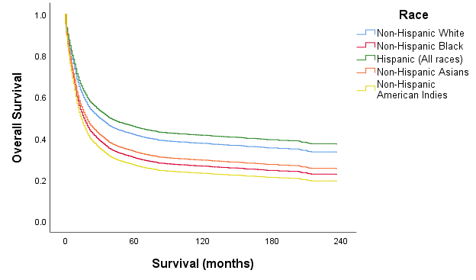

|  |  |  |  |  |  |
| --- | --- | --- | --- | --- | --- |
| **No. at risk** | **0** | **60** | **120** | **180** | **240** |
| **Non-Hispanic White** | 2689.0 | 763.5 | 420.5 | 162.0 | 21.5 |
| **Black** | 629.5 | 111.0 | 59.0 | 21.0 | 2.0 |
| **Hispanic** | 761.5 | 184.5 | 84.0 | 27.0 | 2.5 |
| **Asian or Pacific Islander** | 577.5 | 85.0 | 25.5 | 8.5 | 2.0 |
| **American Indian** | 24.5 | 5.0 | 4.5 | 2.0 | - |

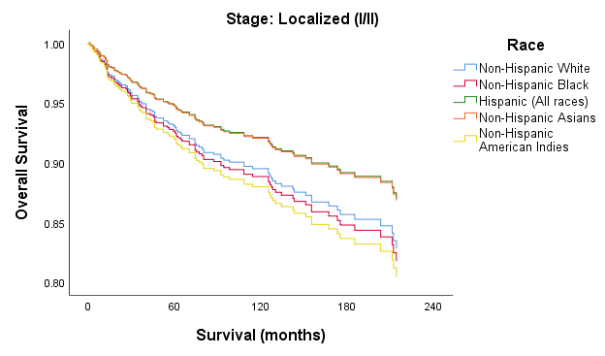

|  |  |  |  |  |  |
| --- | --- | --- | --- | --- | --- |
| **No. at risk** | **0** | **60** | **120** | **180** | **240** |
| **Non-Hispanic White** | 656.5 | 430.5 | 259.0 | 103.5 | 16.5 |
| **Black** | 86.5 | 50.5 | 27.0 | 8.0 | 0.5 |
| **Hispanic** | 162.5 | 96.5 | 48.5 | 15.0 | 1.0 |
| **Asian or Pacific Islander** | 60.0 | 37.5 | 20.0 | 8.0 | 2.0 |
| **American Indian** | 2.5 | 2.0 | 2.0 | 1.0 | - |

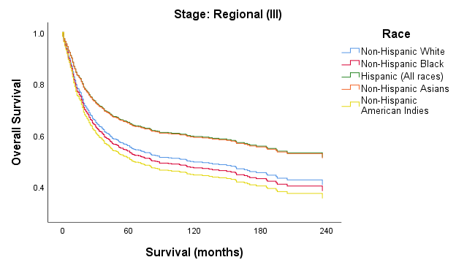

|  |  |  |  |  |  |
| --- | --- | --- | --- | --- | --- |
| **No. at risk** | **0** | **60** | **120** | **180** | **240** |
| **Non-Hispanic White** | 554.5 | 222.5 | 120.0 | 44.0 | 4.0 |
| **Black** | 135.0 | 39.0 | 23.0 | 8.0 | 1.0 |
| **Hispanic** | 125.0 | 56.5 | 26.5 | 9.5 | 1.5 |
| **Asian or Pacific Islander** | 62.5 | 19.0 | 4.0 | 0.5 | - |
| **American Indian** | 5.5 | 2.0 | 1.5 | 0.5 | - |

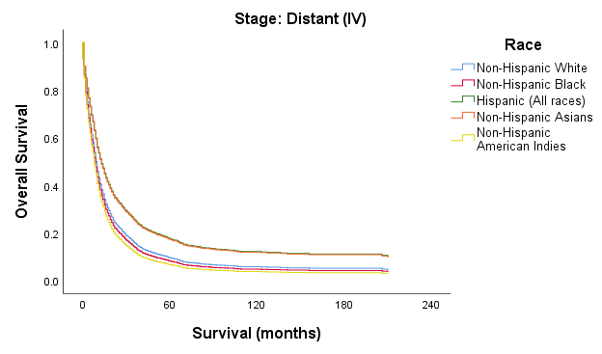

|  |  |  |  |  |  |
| --- | --- | --- | --- | --- | --- |
| **No. at risk** | **0** | **60** | **120** | **180** | **240** |
| **Non-Hispanic White** | 1423.0 | 89.0 | 26.5 | 7.0 | 0.5 |
| **Black** | 396.0 | 19.0 | 8.0 | 4.5 | 0.5 |
| **Hispanic** | 457.5 | 27.0 | 6.5 | 1.5 | - |
| **Asian or Pacific Islander** | 444.0 | 25.0 | 1.5 | - | - |
| **American Indian** | 15.5 | 1.0 | 1.0 | 0.5 | - |

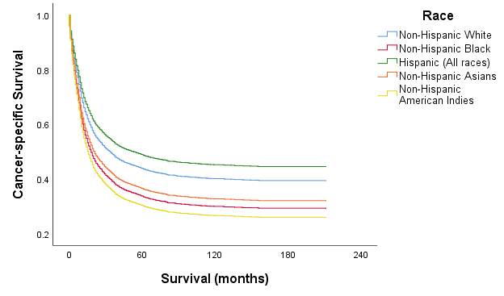

|  |  |  |  |  |  |
| --- | --- | --- | --- | --- | --- |
| **No. at risk** | **0** | **60** | **120** | **180** | **240** |
| **Non-Hispanic White** | 2652.0 | 757.0 | 411.0 | 156.0 | 156.0 |
| **Black** | 614.0 | 109.0 | 57.5 | 20.0 | 2.0 |
| **Hispanic** | 743.5 | 183.0 | 83.0 | 26.5 | 2.5 |
| **Asian or Pacific Islander** | 562.5 | 84.0 | 25.5 | 8.5 | 2.0 |
| **American Indian** | 23.5 | 5.0 | 4.5 | 2.0 | - |

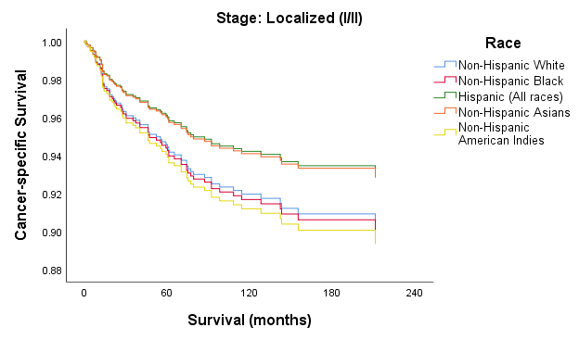

|  |  |  |  |  |  |
| --- | --- | --- | --- | --- | --- |
| **No. at risk** | **0** | **60** | **120** | **180** | **240** |
| **Non-Hispanic White** | 652.5 | 428.5 | 254.5 | 101.5 | 16.5 |
| **Black** | 85.0 | 50.5 | 26.5 | 8.0 | 0.5 |
| **Hispanic** | 161.0 | 96.0 | 48.0 | 15.0 | 1.0 |
| **Asian or Pacific Islander** | 60.0 | 37.5 | 20.0 | 8.0 | 2.0 |
| **American Indian** | 2.5 | 2.0 | 2.0 | 1.0 | - |

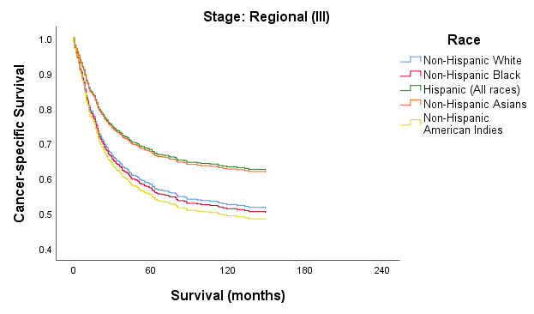

|  |  |  |  |  |  |
| --- | --- | --- | --- | --- | --- |
| **No. at risk** | **0** | **60** | **120** | **180** | **240** |
| **Non-Hispanic White** | 546.5 | 221.5 | 116.0 | 41.5 | 4.0 |
| **Black** | 132.0 | 38.0 | 22.5 | 8.0 | 1.0 |
| **Hispanic** | 123.0 | 56.0 | 26.5 | 9.5 | 1.5 |
| **Asian or Pacific Islander** | 60.5 | 19.0 | 4.0 | 0.5 | - |
| **American Indian** | 5.5 | 2.0 | 1.5 | 0.5 | - |

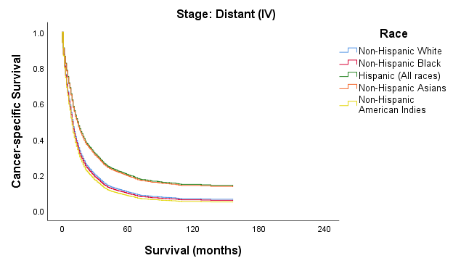

|  |  |  |  |  |  |
| --- | --- | --- | --- | --- | --- |
| **No. at risk** | **0** | **60** | **120** | **180** | **240** |
| **Non-Hispanic White** | 1400.0 | 87.0 | 26.5 | 7.0 | 0.5 |
| **Black** | 385.0 | 18.5 | 7.5 | 3.5 | 0.5 |
| **Hispanic** | 443.5 | 26.5 | 6.0 | 1.5 | - |
| **Asian or Pacific Islander** | 431.5 | 24.5 | 1.5 | - | - |
| **American Indian** | 14.5 | 1.0 | 1.0 | 0.5 | - |

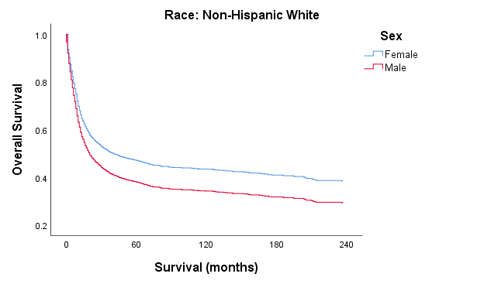

|  |  |  |  |  |  |
| --- | --- | --- | --- | --- | --- |
| **No. at risk** | **0** | **60** | **120** | **180** | **240** |
| **Female** | 1382.0 | 429.5 | 229.0 | 84.5 | 9.0 |
| **Male** | 1307.0 | 334.0 | 191.5 | 77.5 | 12.5 |
|  |  |  |  |  |  |

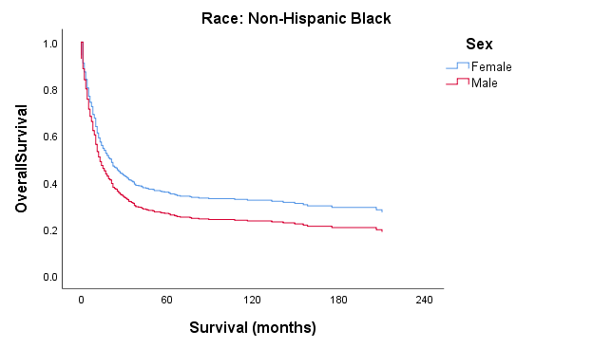

|  |  |  |  |  |  |
| --- | --- | --- | --- | --- | --- |
| **No. at risk** | **0** | **60** | **120** | **180** | **240** |
| **Female** | 287.5 | 56.5 | 29.5 | 11.5 | 2.0 |
| **Male** | 342.0 | 54.5 | 29.5 | 9.5 | - |
|  |  |  |  |  |  |

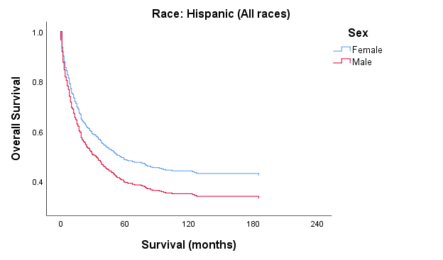

|  |  |  |  |  |  |
| --- | --- | --- | --- | --- | --- |
| **No. at risk** | **0** | **60** | **120** | **180** | **240** |
| **Female** | 386.5 | 103.0 | 49.5 | 17.5 | 1.5 |
| **Male** | 375.0 | 81.0 | 34.5 | 9.5 | 1.0 |
|  |  |  |  |  |  |

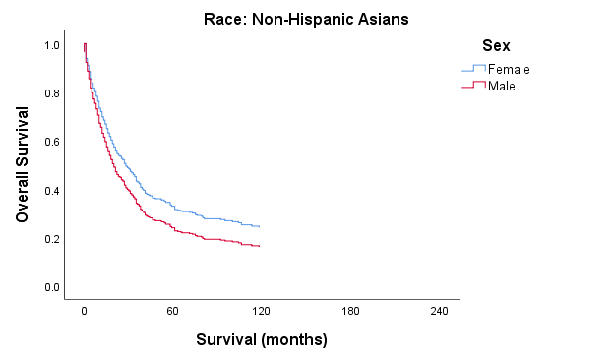

|  |  |  |  |  |  |
| --- | --- | --- | --- | --- | --- |
| **No. at risk** | **0** | **60** | **120** | **180** | **240** |
| **Female** | 300.5 | 50.0 | 14.0 | 5.5 | 1.5 |
| **Male** | 277.0 | 35.0 | 11.5 | 3.0 | 0.5 |
|  |  |  |  |  |  |

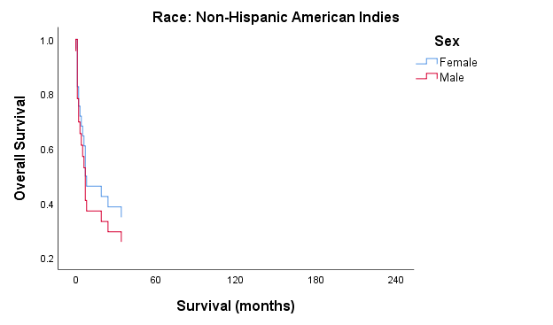

|  |  |  |  |  |  |
| --- | --- | --- | --- | --- | --- |
| **No. at risk** | **0** | **60** | **120** | **180** | **240** |
| **Female** | 13.0 | 2.0 | 1.5 | 0.5 | - |
| **Male** | 11.5 | 3.0 | 3.0 | 1.5 | - |
|  |  |  |  |  |  |

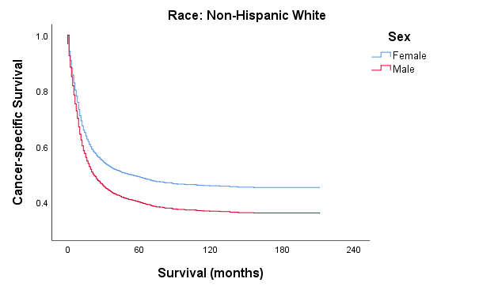

|  |  |  |  |  |  |
| --- | --- | --- | --- | --- | --- |
| **No. at risk** | **0** | **60** | **120** | **180** | **240** |
| **Female** | 1363.0 | 426.5 | 225.5 | 81.5 | 9.0 |
| **Male** | 1289.0 | 330.5 | 185.0 | 74.5 | 12.5 |
|  |  |  |  |  |  |

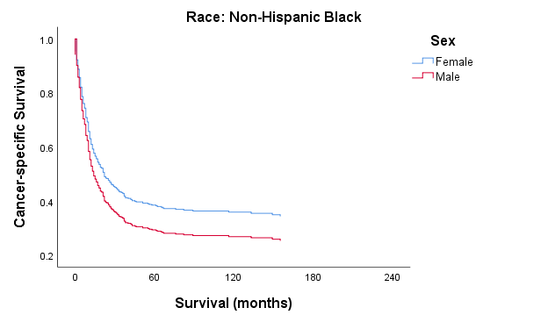

|  |  |  |  |  |  |
| --- | --- | --- | --- | --- | --- |
| **No. at risk** | **0** | **60** | **120** | **180** | **240** |
| **Female** | 282.0 | 55.0 | 28.0 | 11.0 | 2.0 |
| **Male** | 332.0 | 54.0 | 29.5 | 9.0 | - |
|  |  |  |  |  |  |

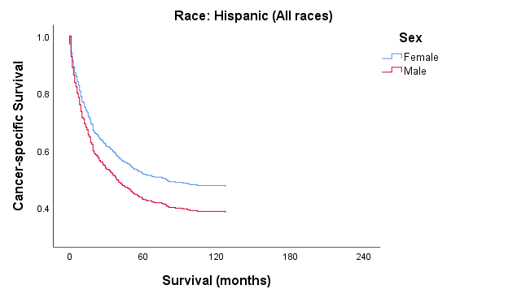

|  |  |  |  |  |  |
| --- | --- | --- | --- | --- | --- |
| **No. at risk** | **0** | **60** | **120** | **180** | **240** |
| **Female** | 379.5 | 103.0 | 49.0 | 17.0 | 1.5 |
| **Male** | 364.0 | 80.0 | 34.0 | 9.5 | 1.0 |
|  |  |  |  |  |  |

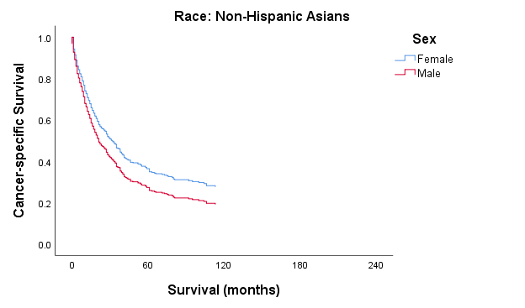

|  |  |  |  |  |  |
| --- | --- | --- | --- | --- | --- |
| **No. at risk** | **0** | **60** | **120** | **180** | **240** |
| **Female** | 290.5 | 49.0 | 14.0 | 5.5 | 1.5 |
| **Male** | 272.0 | 35.0 | 11.5 | 3.0 | 0.5 |
|  |  |  |  |  |  |
|  |  |  |  |  |  |

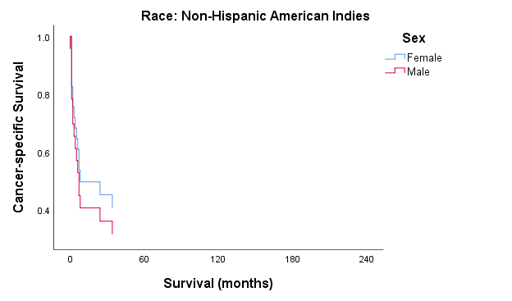

|  |  |  |  |  |  |
| --- | --- | --- | --- | --- | --- |
| **No. at risk** | **0** | **60** | **120** | **180** | **240** |
| **Female** | 13.0 | 2.0 | 1.5 | 0.5 | - |
| **Male** | 10.5 | 3.0 | 3.0 | 1.5 | - |
|  |  |  |  |  |  |